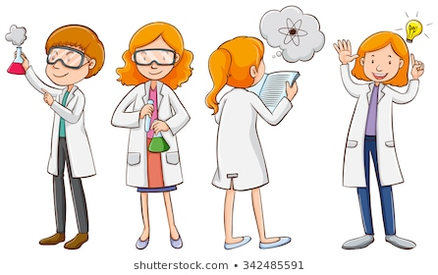Year 7 Science Practical Assessment

Kolbe Catholic College Term 1, 2021

Working as a scientist

Name: __________________

Teacher: _________________

In this task you will be demonstrating all the skills you have learnt that will help you work as a scientist. This assessment will be completed in three parts and you will present all of your findings on a Keynote that will be provided to you. Your slides will include images, descriptions, and drawing on the following topics we have covered in class. Follow the marking key to get your best possible mark.

**Part 1**

*The following will be completed in one class period on ____________ as a stations activity in small groups.*

* Photos of three differences between the Science Laboratory and your Year 7 class, and what safety precautions need to be taken for that difference *(3 marks)*
* Photos of three types of safety equipment in the Science Laboratory and what they are used for *(3 marks)*
* Four rules that need to be followed in the Science Laboratory, with an image for each one *(4 marks)*
* Three types of laboratory equipment with photos, scientific drawings, and descriptions of what they are used for *(6 marks)*

**Part 2**

*The following will be completed in pairs in one class period on __________*

* A video of you correctly lighting the Bunsen burner with a description of each step. *(5 marks)*

**Part 3**

*The following will be completed individually in one class period on ____________*

* Take a photo of the boiling water experiment.
* Annotate the image with a quantitative observation, a qualitative observation and an inference. *(3 marks)*
* Draw a correct scientific drawing of the experiment. *(4 marks)*

Marks are also allocated to how well you follow your teacher’s instructions and your time management during the three parts *(2 marks).* All parts of the task must be added to your Keynote and submitted by the due date _____________

Marking Key

For science assessments, teachers often use marking keys to mark your work. The marking key below is what your teacher will use to mark you Keynote. Notice how many marks each part is worth, and what you need to do to achieve those marks. You can use this marking key to make sure you have completed every part of the task before submitting your work.

|  |  |  |
| --- | --- | --- |
| **Question** | **Criteria** | **Mark** |
| Differences in the lab | Image of difference (0.5)  Description of risks to do with the difference (0.5) | /3 |
| Safety equipment | Image of safety equipment (0.5)  Description of what it is used for (0.5) | /3 |
| Science laboratory rules | Identify science lab rule (0.5)  Image of someone following the rule (0.5)  *\*Must be a science lab rule, not general classroom rule* | /4 |
| Laboratory equipment | Image and name of equipment (1)  Description of what it is used for and correct scientific drawing of equipment (1) | /6 |
| Bunsen Burner | Correctly lights Bunsen Burner following all correct safety steps (4, less 1 mark per mistake). Steps are outlined correctly verbally or in written format on slide (1). | /5 |
| Boiling water | Clear image of experiment showing all equipment.  Image is annotated with correct qualitative and quantitative observation (3).  Correct scientific drawing of experiment done with a ruler and pencil or iPad equivalent (4, less one mark per mistake) | /7 |
| Self-Management | Student followed teacher instructions, did not waste time, followed all class and laboratory rules, and worked well with their peers. | /2 |
| **Total** | | **/30** |

Teacher feedback:

___________________________________________________________________________

___________________________________________________________________________

___________________________________________________________________________

Student reflection:

___________________________________________________________________________

___________________________________________________________________________

___________________________________________________________________________

